**Build A Mobile App**

|  |  |
| --- | --- |
| Team ID | PNT2022TMID50829 |
| Project Name | Real-time river water quality monitoring and control system |

**Design Your UI To Display The Water Turbidity, PH Values**

LogIn Page

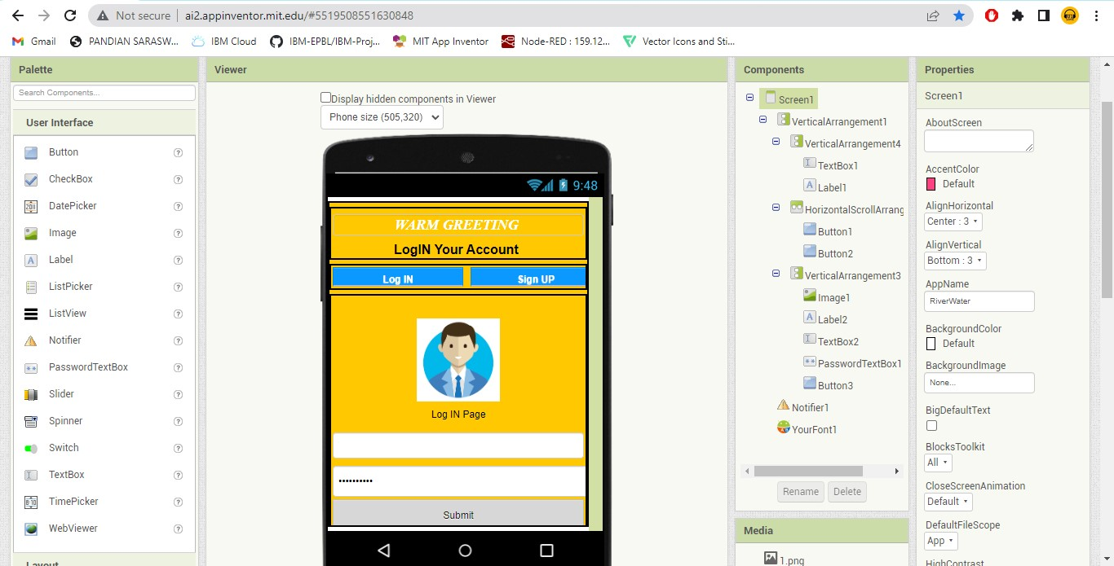

SignUp Page

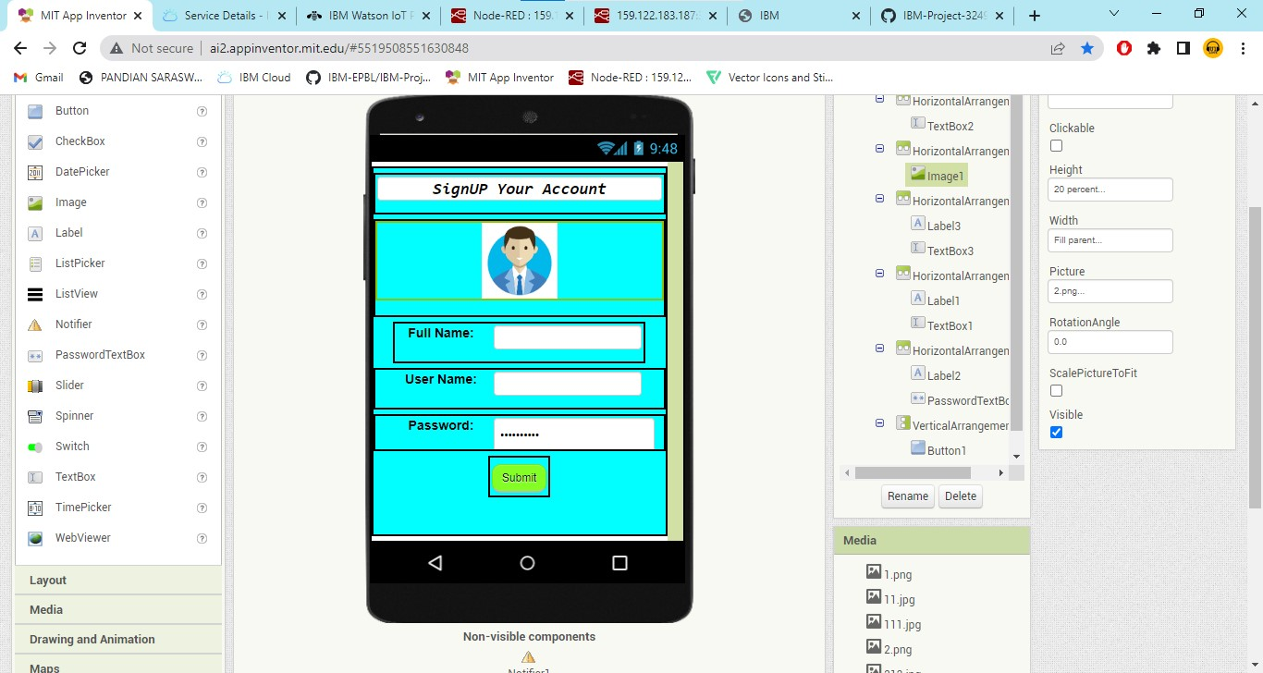

Monitoring Window

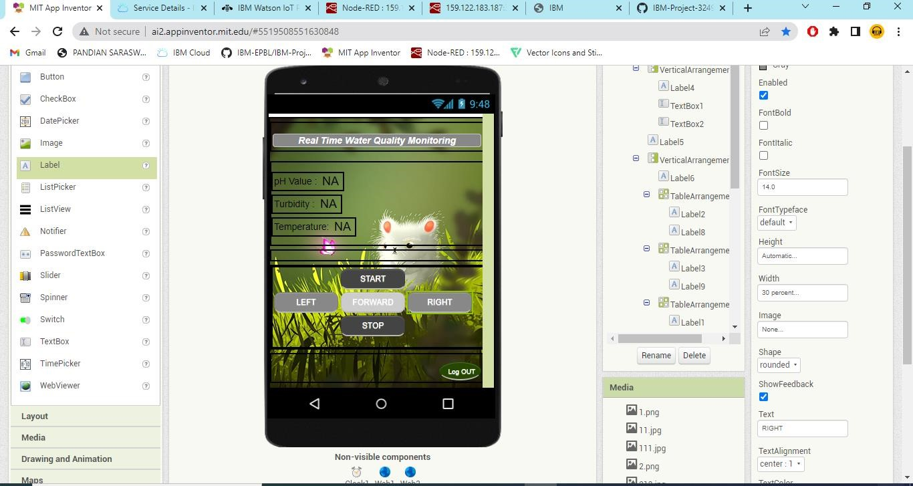

Mobile version

